# Project Assignment 1

**Shaotian Wu Chenting Zhang**

The Gaussian Distribution

Task 1:

For discrete random variable, we could calculate the mean of the variance of each sequence by using the formula as follows:

$$m_{x}=E\left(x\right)=\frac{1}{n}\sum_{i=1}^{n}{x_{i}}$$

$${var}_{x}=\frac{1}{n}\sum_{i=1}^{n}{ {\left(x_{i}-m_{x}\right)}^{2}}$$

Thus, the images of each empirical distribution sequence could be drawn as follows:



When $N_{i}$ increases, the empirical distribution is much closer to the real Gaussian distribution.

Task 2:

For joint Gaussian distribution $f_{XY}(x,y)$, the two-dimensional probability density function of a vector [x, y] is written as follows:

$$f\left(x,y\right)=\frac{1}{2πσ_{1}σ_{2}\sqrt{1-ρ^{2}}}exp⁡\{-\frac{1}{2\left(1-ρ^{2}\right)}[{\left(\frac{x-u_{1}}{σ_{1}}\right)}^{2}-2r+{(\frac{y-u_{2}}{σ_{2}})}^{2}]\}$$

Where $ρ$ is the correlation between X and Y and where $σ_{1}>0$ and $σ_{2}>0$

$$ρ=\frac{cov(X,Y)}{σ_{x}σ_{y}}$$

The correlation coefficient is a number calculated from given data that measures the strength of the linear relationship between two variables: x and y. The sign of the correlation coefficient indicates the direction of the linear relationship between x and y. When $ρ$ is near 1 or −1, the linear relationship is strong; when it is near 0, the linear relationship is weak.

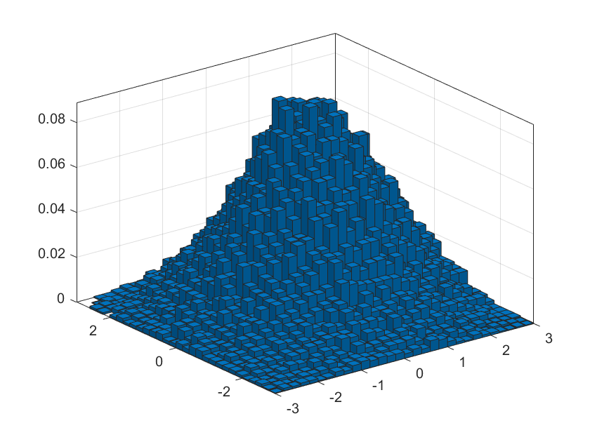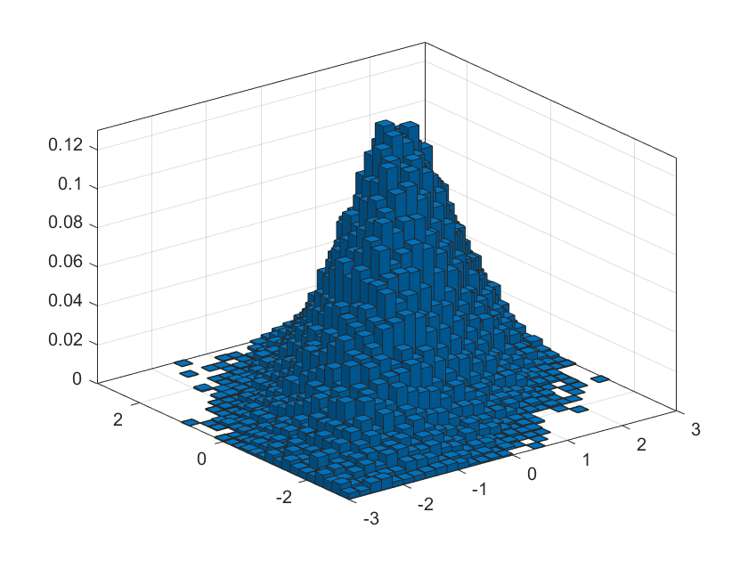

We know that the correlation coefficient $ρ$ between X and Y takes one of the values {0.25, 0.75}, so we could draw from the pictures(.. and ..) that linear relationship between X and Y in sequence2 is strong, so its correlation coefficient $ρ$ is 0.75. Likewise, linear relationship between X and Y in sequence1 is week, so its correlation coefficient $ρ$ is 0.25. Apart from that, A negative correlation occurs when the correlation coefficient is less than 0. This is an indication that both variables move in the opposite direction. For example, if one variable increases, the other variable decreases and vice versa.

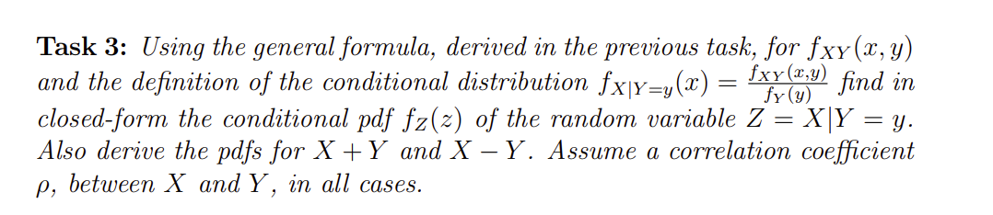

$$f_{X}\left(x\right)=\frac{1}{\sqrt{2πσ^{2}}}exp⁡\{-\frac{{(x-u_{1})}^{2}}{2σ^{2}}\}$$

$$f_{Y}\left(y\right)=\frac{1}{\sqrt{2πσ^{2}}}exp⁡\{-\frac{{(y-u_{2})}^{2}}{2σ^{2}}\}$$

$$f\left(Z=x | Y=y\right)=\frac{f_{XY}\left(x,y\right)}{f_{Y}\left(y\right)}=\frac{\frac{1}{2πσ^{2}\sqrt{1-ρ^{2}}}exp⁡\{-\frac{1}{2\left(1-ρ^{2}\right)}[{\left(\frac{x-u_{1}}{σ}\right)}^{2}-2r+{\left(\frac{y-u_{2}}{σ}\right)}^{2}]\}}{\frac{1}{\sqrt{2πσ^{2}}}exp⁡\{-\frac{{(y-u_{2})}^{2}}{2σ^{2}}\}}=\frac{1}{\sqrt{2πσ^{2}(1-ρ^{2})}}exp⁡\{-\frac{1}{2\left(1-ρ^{2}\right)}[{\left(\frac{x-u_{1}}{σ}\right)}^{2}-2r+ρ^{2}{(\frac{y-u_{2}}{σ})}^{2}]\}$$

Since Gaussian Process is a linear operator, $Z=X+Y$ and $Z=X-Y$ also follow the Gaussian distribution.

$X\sim N(u_{1},σ^{2})$, $Y\sim N\left(u_{2},σ^{2}\right)$, $X+Y\sim N(u_{1}+u_{2},2σ^{2})$, $X-Y\sim N(u_{1}-u_{2},2σ^{2})$

$$f\left(Z | z=x+y\right)=\frac{1}{\sqrt{4πσ^{2}}}exp⁡\{-\frac{{[z-(u_{1}+u_{2})]}^{2}}{4σ^{2}}\}$$

$$f\left(Z | z=x-y\right)=\frac{1}{\sqrt{4πσ^{2}}}exp⁡\{-\frac{{[z-(u_{1}-u_{2})]}^{2}}{4σ^{2}}\}$$